In this lab we will create an app named ReadIt locally to our machine. We will be using this app through our course for testing multiple scenarios.

**Create a Readit app on our PC**

1. First we will create and run the app locally in our laptop
2. For this we need some pre-requisites.
3. Download and install dotnet, for this open below link

<https://dotnet.microsoft.com/en-us/download/dotnet/8.0>

download and install below version sdk package as per your laptop OS. Once downloaded, install the package keeping all options default

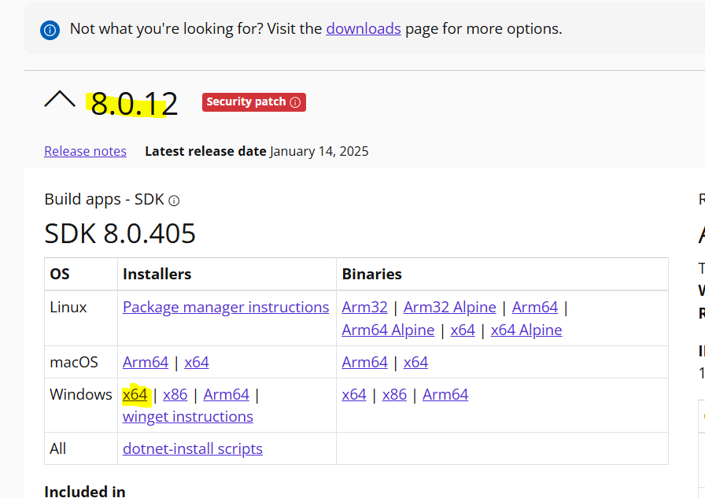

1. Download and install vscode, can use below link

<https://code.visualstudio.com/download>

Download as per your OS, and install it keeping all options default

1. Install extensions in VScode, go to extension button

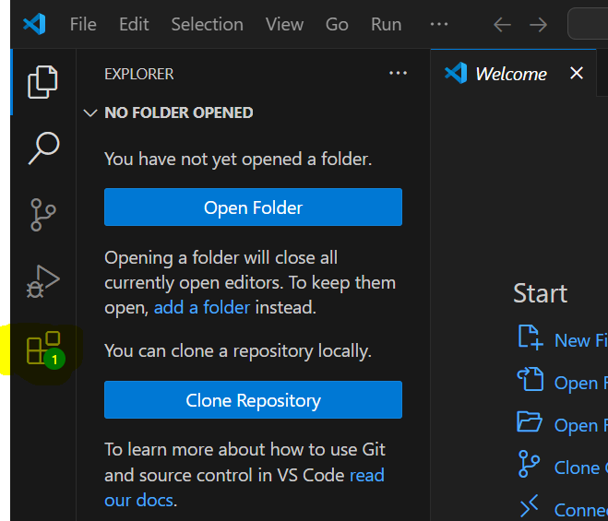

1. Search for c#, and install C# extension

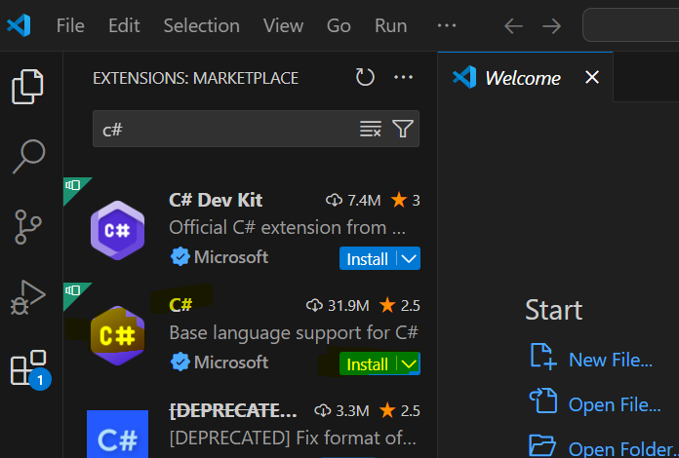

1. Search for Google code, this extension is for GCP, install google cloud code extension

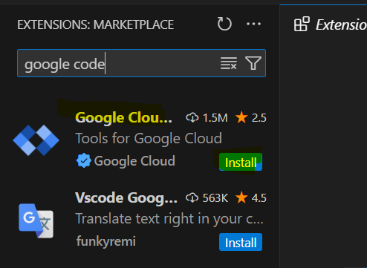

1. Now extract the catalog folder and go to C drive, make a new folder and name it Readit, then copy the catalogue folder to Readit folder

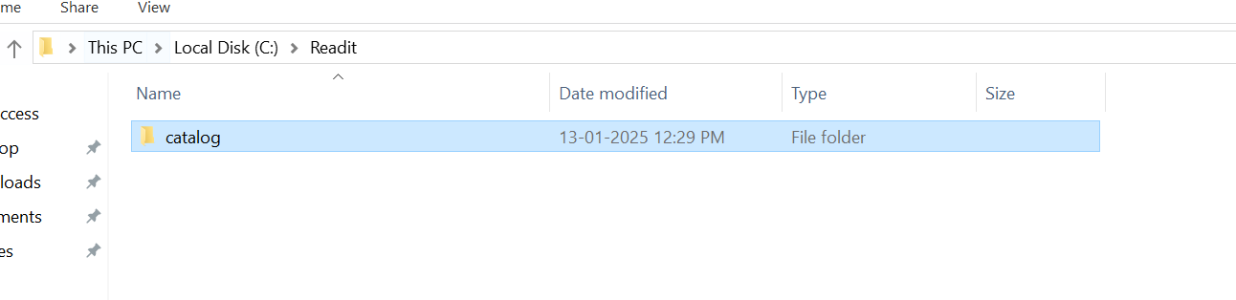

1. Open catalog folder, right click and open with Visual Studio.

If option not showing there, then manually go to VSCode and open folder from there

1. Go to View, click command Palette

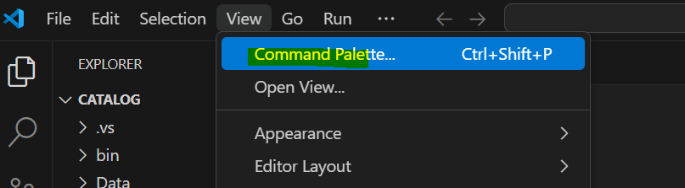

1. Click .Net: Generate Assets for Build and Debug

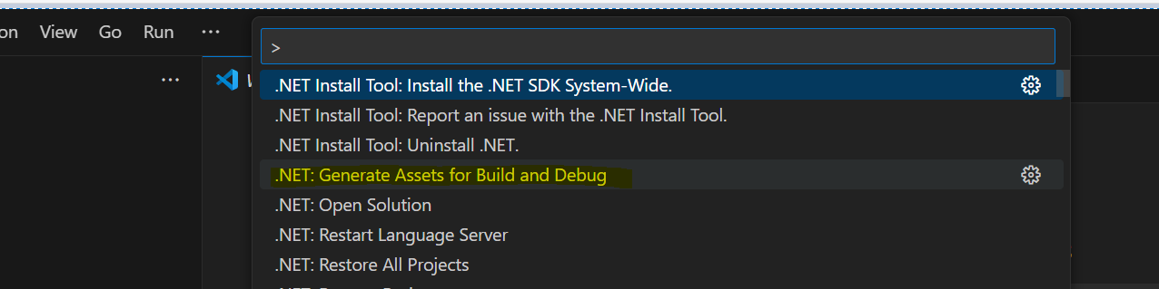

1. Press F5, this will start building the project. If you see any message, click yes.

This will open a webpage with address <https://localhost:5001/> (In case it give any error, open it in chrome)

Click Load books to DB

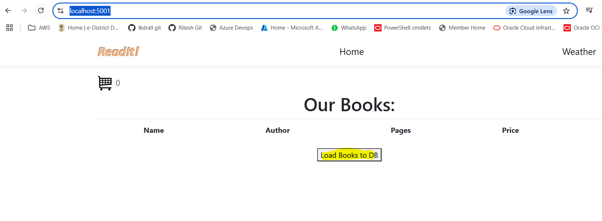

1. After loading books, the page must look like below

